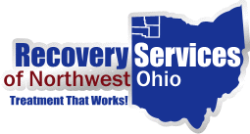
Agency Response to Corona Virus (COVID19) During Stay at Home Order
Recovery Services of Northwest Ohio (RSNWO) takes great pride in the quality and accessibility of the services that we provide through all levels of care. During this very unprecedented time, RSNWO wants to keep you informed of the actions we are taking to ensure that we can continue to provide these services while keeping clients and staff safe and healthy. Telemedicine/Telephone Services will be made available for assessments, individual counseling and case management, medication management, and psychiatry.
Recovery Services is committed to continuing to provide services for our clients during this very difficult time. We will be updating our website, www.rsnwo.org with postings of virtual client support meetings and further developments as we work to ensure continuity of client care.
We are available at 419-782-9920 or 1-855-782-9920. Staff are reaching out to those who have established appointments, and those we are aware that need help.
If you have any questions or need our assistance, please do not hesitate to call.
Take Care and Stay Healthy.

